Long Distance Trains
A Foundation for National Mobility

Long distance train routes form the foundation of the national passenger train network, connecting congested urban areas and bringing economically viable mobility to rural areas and small towns. It is very important to note that many of these areas are becoming more isolated from major cities as regional airline and intercity bus service disappears. In Fiscal 2016, long-distance trains accounted for 41% of all Amtrak intercity passenger-miles. (A passenger-mile is one passenger traveling one mile.)

From 1998 to 2016, ridership on Amtrak’s long-distance trains rose almost 20% even though capacity was not increased In FY 2013, all 15 long-distance routes combined for the best year in 20 years, carrying over 4.8 million passengers. Ridership has held steady in the face of on-time performance issues, with 4.7 million passengers in FY 2016.

NARP advocates transforming the long distance train network from a neglected, barebones operation into a robust and thriving mobility machine, by working to:

1. Lengthen trains, increase frequencies and fill gaps in the national network, creating a comprehensive web of routes that provides convenient connectivity at major hubs;
2. Make track, signal and station improvements that decrease trip times and increase on time performance;
3. Procure high-performance, modern equipment suitable for overnight and longer distance trips.

Such investments would improve mobility and create better access to jobs, economic opportunity, education and vital cultural resources for many Americans.

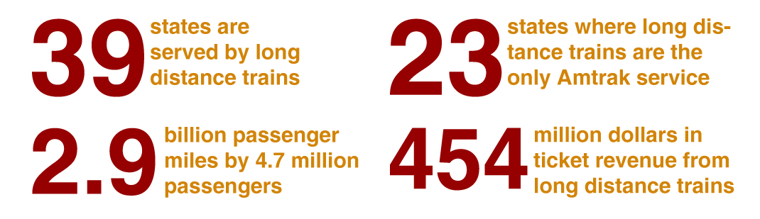

Of Amtrak’s 15 long-distance trains, most have just one daily round-trip and two have just three a week. Nonetheless, these routes are heavily used. They would carry even more passengers if Amtrak had more equipment, greater frequencies and more routes. Lack of service, not lack of demand, is what limits usage.

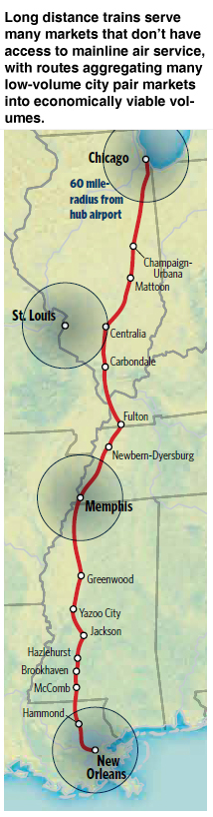Long distance passenger train routes currently perform a significant transportation function, and represent the foundation to build a national passenger train network that would provide new, high quality mobility choices to a large and geographically diverse cross-section of Americans. They are ideal for connecting major urban areas with each other and with smaller cities and communities—many in rural areas—which are becoming more isolated as regional airline and intercity bus services disappear.

Long-distance trains generate high volumes and load factors by:

1. Providing a single seat ride in many overlapping city pair markets;
2. Combining many small markets to generate economic volumes.

Long distance routes are, in essence, connected and overlapping corridors. Many passengers transfer between or among other Amtrak short-distance and long-distance routes. Moreover, the utility and effectiveness of individual routes grow significantly when they become part of an integrated system that provides easy transfers to trains on other routes, feeder buses, local transit systems and airports. Such connectivity serves more people, generates greater revenue, drives economies of scale and improves public mobility. Because these routes can aggregate many low-volume city pair markets into economically viable volumes, long-distance routes are an especially effective way to maximize the number of Americans who would experience the benefits of such investments in a relatively short period of time.

A comprehensive national system with more routes and greater frequencies will require a higher level of public support. But since many of these costs are fixed, expanded service would increase efficiency and lower the public cost per passenger mile.

